Lingaya’s University



Java Lab

(IT-358)

LAB FILE

SUBMITTED TO: SUBMITTED BY:

Sec-A

**EXperiment-1**

**Aim : To write a program in java to print Hello World**

**Code:**

import java.io.*;

import java.util.*;

public class demo {

public static void main(String[] args)

{

System.out.println("Hello World ");

}

}

**Output**:

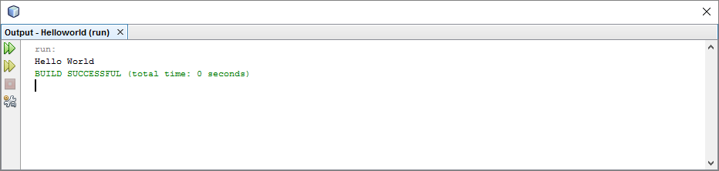

**Experiment-2**

**Aim :a) To write a program in java to print area of rectangle**

**Code:**

public class demo {

public static void main(String[] args)

{

int len,bed;

System.out.println("Enter the Length ");

Scanner obj=new Scanner(System.in);

len=obj.nextInt();

System.out.println("Enter the Breadth ");

bed=obj.nextInt();

int area=len*bed;

System.out.println("The value of the area is "+area);

}

}

**Output**:

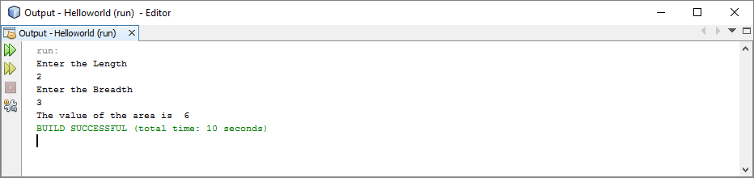

**(b) To write a java program to find the result of the following expressions**

**(i) (a<<2) +(b>>2)**

**(ii) (b>0)**

**(iii) (a+b*100)/10**

**(iv) a & b Assume a=10, b=5**

**Code:**

public class demo {

public static void main(String[] args)

{

int a=10;

int b=5;

System.out.println("(a<<2) +(b>>2)="+((a<<2) + (b>>2)));

System.out.println("b>0 :"+(b>0));

System.out.println("(a+b*100)/10="+(a+b*100)/10);

System.out.println("a & b="+(a & b));

}

}

**Output:**

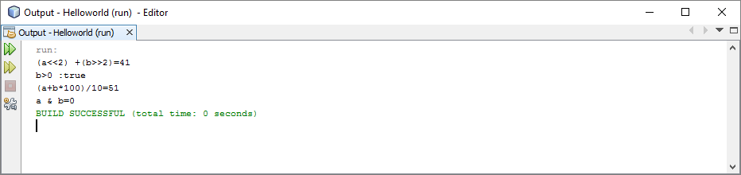

**(c) To write a java program to print the individual digits of a 3 digit number using Command line arguments.**

**Code:**

public class demo {

public static void main(String[] args)

{

int number ,rem,sum=0;

System.out.println("Enter the number ");

Scanner obj=new Scanner(System.in);

number=obj.nextInt();

while(number!=0)

{

rem=number%10;

sum+=rem;

number=number/10;

}

System.out.println("The value of sum is "+sum);

}

}

**Output:**

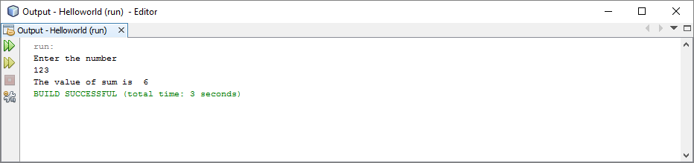

**Experiment-3**

**Aim :** **(a) Write a java program to read two integers and print the larger number. followed by the words “is larger”. If the numbers are equal print the message “These numbers are equal”**

**Code:**

public class demo {

public static void main(String[] args)

{

int len,bed;

System.out.println("Enter the number A ");

Scanner obj=new Scanner(System.in);

len=obj.nextInt();

System.out.println("Enter the number B ");

bed=obj.nextInt();

if (len>bed)

{

System.out.println(len+" Is Lageer tha "+bed);

}

if(bed>len)

{

System.out.println(bed+" Is Lageer tha "+len);

}

if(len==bed)

{

System.out.println(bed+" IS EQUAL TO "+len);

}

}

}

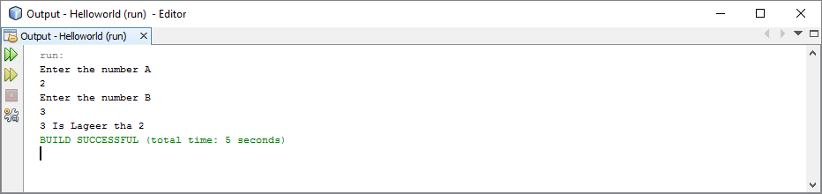

**(b) Write a java program to read an integer and find whether the number is odd or even.**

**Code:**

public class demo {

public static void main(String[] args)

{

int len;

System.out.println("Enter the number A ");

Scanner obj=new Scanner(System.in);

len=obj.nextInt();

if(len%2==0)

{

System.out.println("The Number is Even ");

}

else

{

System.out.println("The Number is Odd ");

}

}

}

**Output:**

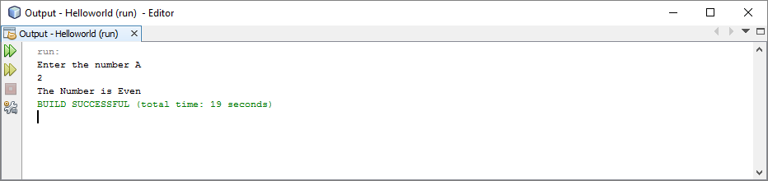

**(c) Write a java program to find the number of and sum of all integers greater than 100 and less than 200 that are divisible by 7.**

**Code:**

public class demo {

public static void main(String[] args)

{

int len=0,nlen=0,sum=0;

for(int i=100;i<200;++i)

{

if(i%7==0)

{

len+=i;

}

else

{

nlen+=i;

}

sum+=i;

}

System.out.println("The sum of the integer is "+sum );

System.out.println("The sum of the integer Divisble by 7 is "+len );

System.out.println("The sum of the integer not Divisble by 7 is "+nlen );

}

}

**Output:**

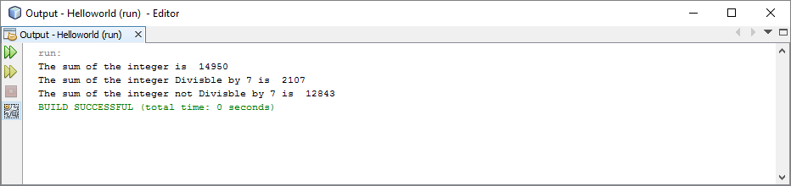

**Experiment-4**

**Aim :** **(a) (a) Write a Java program to find the sum of digits of a given number.**

Source Code:

package exp1;

import java.util.*;

public class Sodigits

{

public static void main(String args[])

{

Scanner sc=new Scanner(System.in);

int a,r,sum=0;

System.out.println("enter a number");

a=sc.nextInt();

while(a!=0)

{

r=a%10;

a=a/10;

sum=sum+r;

}

System.out.println("Sum of digits of a number is "+sum);

}

}

Output:

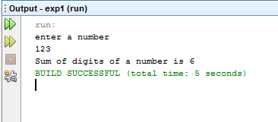

**(B) Aim: WAP to find 15 terms of Fibonacci Series.**

Source Code:

package exp1;

public class fibonacci

{

public static void main(String args[])

{

int n1=0,n2=1,n3,i,count=15;

System.out.print(n1+" "+n2);

for(i=2;i<count;++i)

{

n3=n1+n2;

System.out.print(" "+n3);

n1=n2;

n2=n3;

}

}

}

Output:

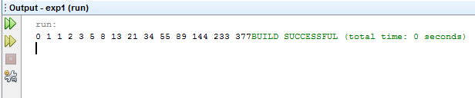

**(C) Aim: WAP to print the Armstrong Number.**

Source Code:

package exp1;

import java.util.*;

public class armstrongnum

{

public static void main(String args[])

{

Scanner sc=new Scanner(System.in);

int sum=0,r,n,temp;

System.out.println("enter a number to check whether it is armstrong no. or not");

n=sc.nextInt();

temp=n;

while(n>0)

{

r=n%10;

n=n/10;

sum =sum+(r*r*r);

}

if(temp==sum)

{

System.out.println("armstrong number");

}

else

{

System.out.println("Not armstrong number");

}

}

}

Output:

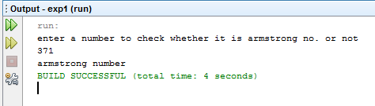

**(D) Aim: WAP using while loop to reverse the digits of the number.**

Source Code:

package exp1;

import java.util.*;

public class revnum

{

public static void main(String args[])

{

int n, reverse = 0;

System.out.println("Enter the number to reverse");

Scanner sc = new Scanner(System.in);

n = sc.nextInt();

while( n != 0 )

{

reverse = reverse * 10;

reverse = reverse + n%10;

n = n/10;

}

System.out.println("Reverse of entered number is "+reverse);

}

}

Output:

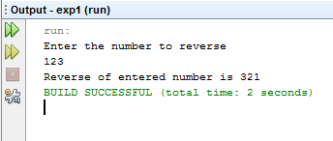

**Experiment-5**

1. **Aim: WAP to display total marks of 5 students.**

Source Code:

package exp1;

import java.util.*;

public class student

{

int regno;

String name;

int marks[]=new int[5];

int total;

void info()

{

Scanner sn=new Scanner(System.in);

System.out.println("Enter regno");

regno=sn.nextInt();

System.out.println("enter name");

name=sn.next();

calculate();

}

void calculate()

{

total=0;

Scanner sc=new Scanner(System.in);

System.out.println("report card of student");

System.out.println("marks of student in eng, phy, chem, maths, cs");

for(int i=0;i<5;i++)

{

marks[i]=sc.nextInt();

total=total+marks[i];

}

}

void display()

{

System.out.println("regno: "+regno+" name: "+name+" total: "+total);

}

public static void main(String args[])

{

student s1=new student();

student s2=new student();

student s3=new student();

student s4=new student();

student s5=new student();

s1.info();

s1.display();

s2.info();

s2.display();

s3.info();

s3.display();

s4.info();

s4.display();

s5.info();

s5.display();

}

}

Output:

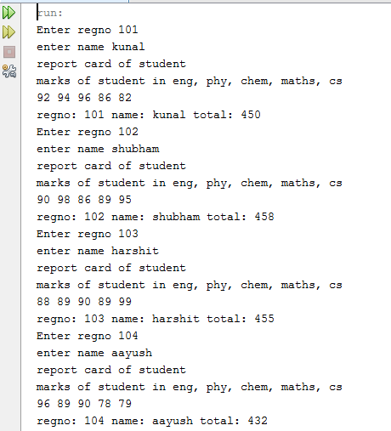

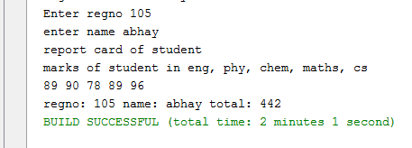

1. **Aim: WAP to find the area of a room using constructor.**

Source Code:

package exp1;

public class area

{

int l,b;

area()

{

l=10;

b=20;

System.out.println("area of room is "+l*b);

}

area(int l, int b)

{

this.l=l;

this.b=b;

System.out.println("area of room is "+l*b);

}

public static void main(String args[])

{

area a1=new area();

area a2=new area(30,40);

}

}

Output:

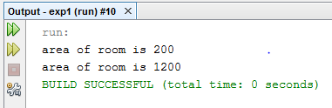

1. **Aim: WAP to implement method overloading.**

Source Code:

package rectangle;

public class fovld

{

int fun1(int a)

{

int b;

b=a;

System.out.println(b);

return b;

}

float fun1(float b)

{

float c;

c=b;

System.out.println(c);

return c;

}

long fun1(int c,int e)

{

int h=c;

int g=e;

System.out.println(h+" "+e);

return g;

}

float fun1(int c,float e)

{

float h=c;

float g=e;

System.out.println(h+" "+e);

return g;

}

public static void main(String args[])

{

fovld f1=new fovld();

f1.fun1(10);

f1.fun1(22.5f);

f1.fun1(10,20.5f);

f1.fun1(27,47);

}

}

Output:

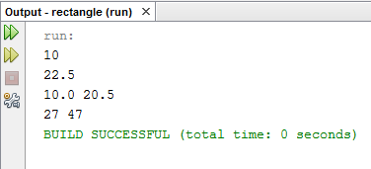

1. **Aim: WAP to show the use of “static” members.**

Source Code:

package exp1;

import java.util.*;

public class smem

{

int roll_no;

String name;

static String city="Delhi";

void info()

{

Scanner sc=new Scanner(System.in);

System.out.println("enter roll no.");

roll_no=sc.nextInt();

System.out.println("enter name");

name=sc.next();

}

void display()

{

System.out.println("roll no. is "+roll_no+" name is "+name+" city is "+city);

}

static void show()

{

System.out.println("city will be "+city+" for every object of this class");

}

public static void main(String args[])

{

smem.show();

smem s1=new smem();

smem s2=new smem();

s1.info();

s1.display();

s2.info();

s2.display();

}

}

Output:

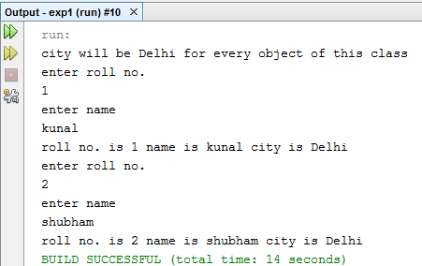

1. **Aim: WAP to implement the nesting of methods.**

Source Code:

package exp1;

class Nesting1

{

int m,n;

Nesting1(int x,int y)

{

m=x;

n=y;

}

int largest()

{

if(m>=n)

{

return m;

}

else

{

return n;

}

}

void display()

{

int large=largest();

System.out.println("largest value is "+large);

}

}

class Nesting

{

public static void main(String args[])

{

Nesting1 nest=new Nesting1(50,40);

nest.display();

}

}

Output:

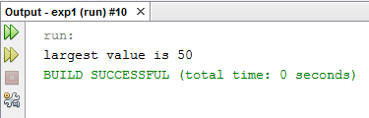

**EXPERIMENT NO. 6**

**AIM: (a) Write a Java Program to find the largest and smallest number in an array.**

public class LargestSmallestnum

{

public static void main(String[] args)

{

int no[] = new int[]{42,48,33,44,32,75,83,28,53,13,88,99,33,44,55};

int small = no[0];

int large = no[0];

for(int i=1; i< no.length; i++)

{

if(no[i] > large)

large = no[i];

else if (no[i] < small)

small = no[i];

}

System.out.println("The Largest number is : " + large);

System.out.println("The Smallest number is : " + small);

}

}

**Output:**

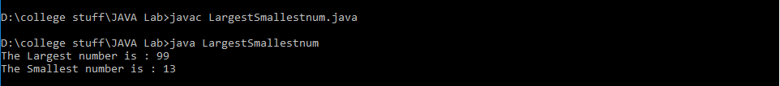

**(b) Write a java program to multiply two matrices**

import java.util.Scanner;

public class Matrix_mul {

public static void main(String[] args) {

Scanner s = new Scanner(System.in);

System.out.print("Enter number of rows in A: ");

int rowsInA = s.nextInt();

System.out.print("Enter number of columns in A / rows in B: ");

int columnsInA = s.nextInt();

System.out.print("Enter number of columns in B: ");

int columnsInB = s.nextInt();

int[][] a = new int[rowsInA][columnsInA];

int[][] b = new int[columnsInA][columnsInB];

System.out.println("Enter matrix A");

for (int i = 0; i < a.length; i++) {

for (int j = 0; j < a[0].length; j++) {

a[i][j] = s.nextInt();

} }

System.out.println("Enter matrix B");

for (int i = 0; i < b.length; i++) {

for (int j = 0; j < b[0].length; j++) {

b[i][j] = s.nextInt();

} }

int[][] c = multiply(a, b);

System.out.println("Product of A and B is");

for (int i = 0; i < c.length; i++) {

for (int j = 0; j < c[0].length; j++) {

System.out.print(c[i][j] + " ");

} System.out.println();

} }

public static int[][] multiply(int[][] a, int[][] b) {

int rowsInA = a.length;

int columnsInA = a[0].length; // same as rows in B

int columnsInB = b[0].length;

int[][] c = new int[rowsInA][columnsInB];

for (int i = 0; i < rowsInA; i++) {

for (int j = 0; j < columnsInB; j++) {

for (int k = 0; k < columnsInA; k++) {

c[i][j] = c[i][j] + a[i][k] * b[k][j];

}}

}

return c;

}

}

**Output:**

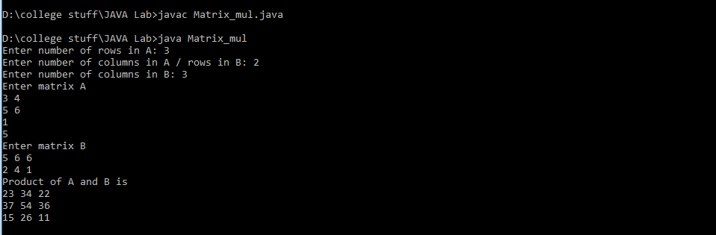

**(c) Write a java program to sort the following numbers in descending order.**

**{55, 40, 80, 65, 71}**

import java.util.Scanner;

public class desc_order {

public static void main(String []args) {

int n, c, d, swap;

Scanner in = new Scanner(System.in);

System.out.println("Input number of integers to sort");

n = in.nextInt();

int array[] = new int[n];

System.out.println("Enter " + n + " integers");

for (c = 0; c < n; c++)

array[c] = in.nextInt();

for (c = 0; c < ( n - 1 ); c++) {

for (d = 0; d < n - c - 1; d++) {

if (array[d] > array[d+1]) /* For descending order use < */

{

swap = array[d];

array[d] = array[d+1];

array[d+1] = swap;

}

}

}

System.out.println("Sorted list of numbers");

for (c = 0; c < n; c++)

System.out.println(array[c]);

}

}

**Output:**

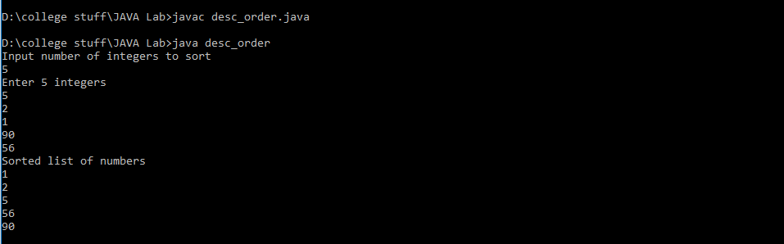

**(d) Write a java program that creates a string object and initializes it with your name and performs the following operations**

1. **To find the length of the string object using appropriate String method.**
2. **To find whether the character ‘a’ is present in the string. If yes find the number of times ‘a’ appear in the name and the location where it appears.**

import java.util.Scanner;

public class JavaApplication17

{

public static void main(String[] args)

{

Scanner bb=new Scanner(System.in);

System.out.println("Enter your name");

String name=bb.nextLine();

int count=0;

System.out.println("The given name is "+name);

System.out.println("The length of name is "+name.length());

if(name.indexOf('a')<0)

System.out.println("The character 'a' is not present in my name");

else

{

System.out.println("The character 'a' is present in the locations");

int loc=0;

while(loc<name.lastIndexOf('a'))

{

int x=name.indexOf('a',loc);

System.out.println(x);

loc=x+1;

count++;

}

}

System.out.println("The character 'a' is present "+count+" times");

}

}

**Output:**

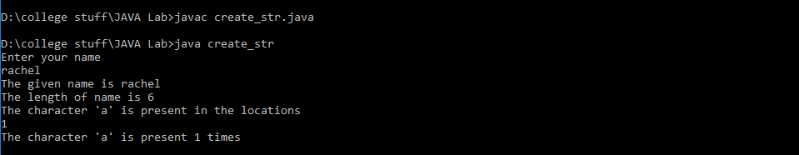

**(e) Write a java program to arrange the following word in alphabetical order**

**{Madras, Delhi, Ahmadabad, Calcutta, Bombay}**

public class ArrangeWord {

public static void main(String[] args) {

System.out.println("\nThe original sequence of words are :"+" Madras, Delhi,

Ahmadabad, Calcutta, and Bombay");

System.out.println("\nThe Arranged words are :");

System.out.println("");

String arr[]={"Madras", "Delhi", "Ahmadabad", "Calcutta", "Bombay"};

String temp;

for(int i=0;i<arr.length;i++)

{ temp=arr[i];

for(int j=0;j<arr.length;j++)

{

if (i==j) continue;

int x=temp.compareTo(arr[j]);

if(x<0)

{ temp=arr[j];

arr[j]=arr[i];

arr[i]=temp;

}}}

for(int i=0;i<arr.length;i++)

{

System.out.println(arr[i]);

}

}

}

**Output:**

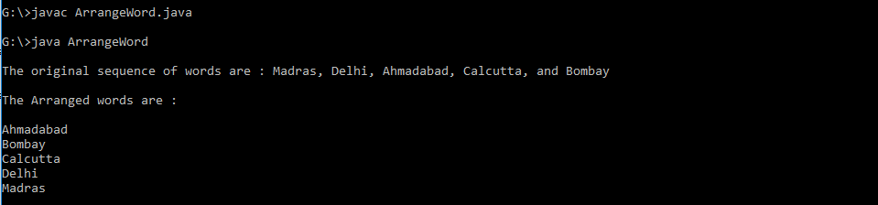

**EXPERIMENT- 7**

1. **AIM:** Write a java program to implement method overriding.

***Source code:***

package mthovr;

class First

{

void show()

{

System.out.println("Show First");

}

}

class Second extends First

{

void show()

{

System.out.println("Show Second");

}

}

public class MthOvr

{

public static void main(String[] args)

{

Second s = new Second();

s.show();

}

}

***Output:***

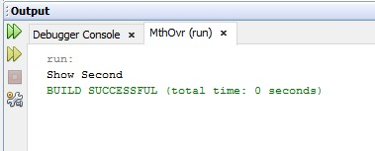

1. **AIM:** Write a java program to implement multiple inheritance.

***Source code:***

package multipleinh;

interface First

{

void alpha();

}

interface Second

{

void beta();

}

class Third implements First,Second

{

public void alpha()

{

System.out.println("Print Alpha");

}

public void beta()

{

System.out.println("Print Beta");

}

}

public class MultipleInh

{

public static void main(String[] args)

{

Third t = new Third() {};

t.beta();

t.alpha();

}

}

***OUTPUT :***

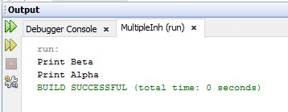

1. **AIM:** Write a java program to implement single inheritance using super keyword.

***Source code:***

package superinh;

class Person

{

void message()

{

System.out.println("Parent Class message");

}

}

public class SuperInh extends Person

{

void message()

{

System.out.println("Child Class Message");

}

void display()

{

message();

super.message();

}

public static void main(String[] args)

{

SuperInh s = new SuperInh();

s.display();

}

}

***OUTPUT :***

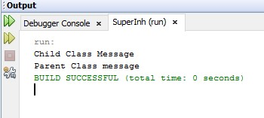

**Experiment-8**

**(a)Write a program to create your own package and use that package in another program to print “ Hello package”.**

**FILE-1:**

package hello;

public class hell {

public void display(){

System.out.println("Hello Packages");

}

}

**FILE-2:**

package javaapplication23;

import hello.*;

public class JavaApplication23 {

public static void main(String[] args) {

hell h1 = new hell();

h1.display();

}

}

**OUTPUT:-**

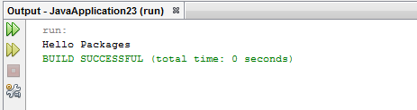

**(b) Write a program in java to implement multithreading.**

**SOURCE CODE :**

class Test extends Thread

{

public void run()

{

System.out.println("First Thread started...");

try

{

for(int i=1;i<10;i++)

{

Thread.sleep(1000); // 1 second

System.out.println("First Thread is Running... "+i);

}

System.out.println("First Thread completed...");

}

catch(Exception e){}

}

}

class ThreadTest4

{

public static void main(String args[]) throws Exception

{

System.out.println("Main Thread started...");

Test t = new Test();

t.start();

for(int i=10;i>1;i--)

{

Thread.sleep(1000);

System.out.println("Main Thread is Running... "+i);

if(i==5)

{

t.join();

}

}

System.out.println("Main Thread completed...");

}

}

**OUTPUT:**

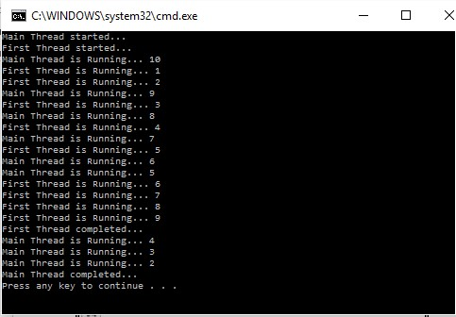

**Experiment-9**

**AIM: A) Write a java program to print “ Hello applets” using applets.**

**SOURCE CODE :**

import java.applet.Applet;

import java.awt.Graphics;

public class NewApplet extends Applet

{

public void paint(Graphics g)

{

g.drawString("Hello applet!", 50, 25);

}

}

**OUTPUT:**

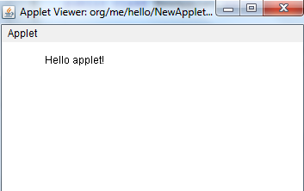

**B) Write a java program to implement multiple try/catch statements.**

**SOURCE CODE :**

class ExceptionHandling6

{

public static void main(String args[])

{

try

{

System.out.println("first try block");

int x=10/0;

System.out.println("first try block end");

}

catch(ArithmeticException e)

{

try

{

System.out.println("Second try block");

String s=null;

System.out.println(s.equals(""));

}

catch(NullPointerException n)

{

System.out.println(n);

}

System.out.println("Number cannot be divide by zero");

}

System.out.println("End of Main");

}

}

**OUTPUT:-**

